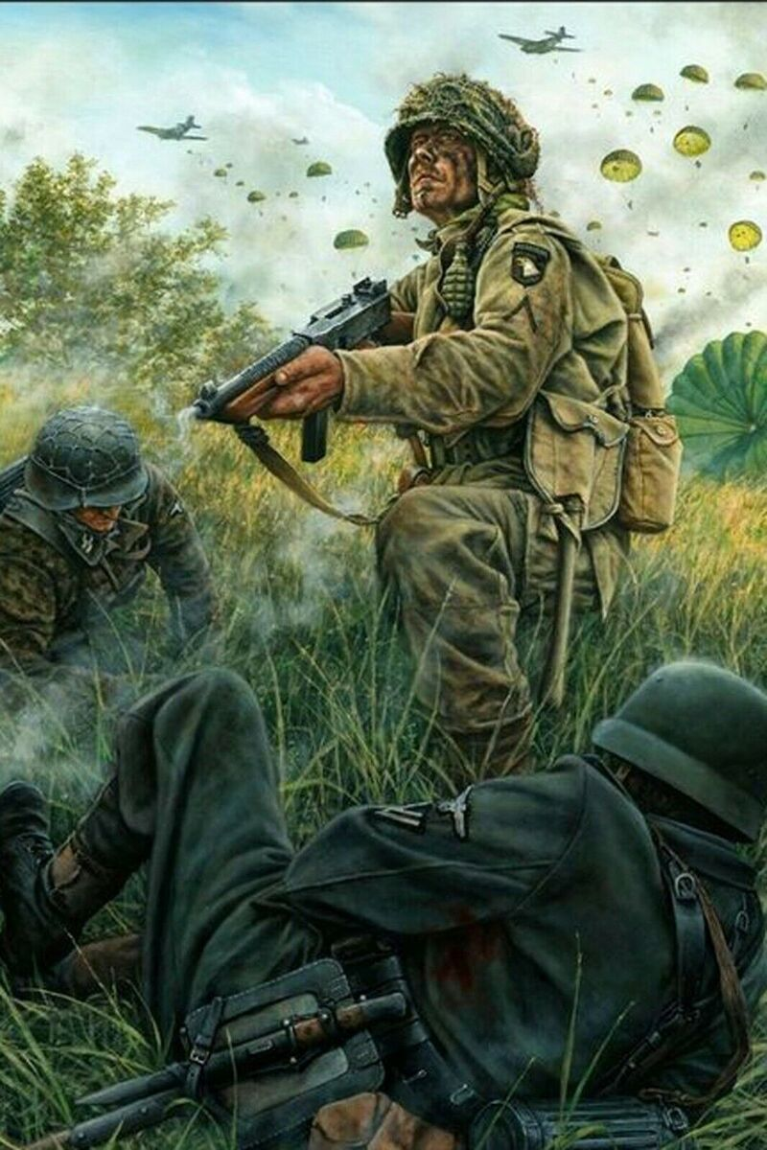

BLOOD UPON THE RISERS

A One-Day Bolt action introductory event

“There was blood upon the risers….And he ain’t gonna jump no more!”- US Airborne song, WW2.

**Outline**

This FREE admission event is suitable for new players who haven’t attended an event before, or have been away from the game for some time.

The event will take place on 23 December 2024 in Burnham Military Camp (BMC), Christchurch. Exact details will be given on registration. There will be three rounds of Bolt Action played, using V3 of the Bolt Action rules and current official FAQ/Errata.

Players must be 18 or over and with photo ID due to the location of the event, and player numbers will be capped at 10 due to space available in the venue.

**The Structure of the Day**

22nd Dec - table set up for all gaming tables & terrain by Dan/Andy/Craig, Timings TBC.

23rd Dec:

0815 Registration (player arrival) and quick brief, followed by three games:

0900 - 1130 Game 1

1130 - 1225 Lunch

1230 - 1500 Game 2

1530 - 1800 Game 3

1800 – 1900 Pack up & Presentations

**Game Duration**

Games will be limited to a maximum of 2 hours 30 mins and timings will be adjusted where possible to bring things forward should all games finish earlier.

**Finishing Games**

Games should be played through to their full game length where possible within the scenarios and allocated time. Should a game still be in progress nearing the end of the 2 hrs 30 minutes then games should play on, drawing dice and activating units until time is called- at which time the current dice drawn (not a multiple-die ‘snap-to’ action) is to be resolved and the game will end.

**Scoring & Event Results**

Results will be calculated as follows:

Win: 3 points

Draw: 1 point

Loss: 0 points

Additional points are also available in each game for:

1. Players reaching any point of the 5th turn or later in their game: 1 point each player.
2. Players achieving a secondary objective (up to 2 per game- details below): 1 point each.

***Example;*** *Johnny Frost has won his game against Ivan Chestikoff (3 points). They played into the fifth turn before having to stop due to time (1 point), and Johnny achieved a secondary objective (1 point). Although Ivan lost (0 points), he played into the fifth turn (1 point) and also achieved a secondary objective (1 point). Total game score entered on the results sheet and handed in to the TO; Johnny 5 pts, Ivan 2 points, with the secondary objectives the players used written on the sheet also.*

The placings for the event will be calculated by cumulative points achieved throughout the event.

**Secondary Objectives**

In addition to the victory conditions specified by the scenario being played, a series of minor objectives will be available to every player to achieve during their games.

Each objective can be claimed once over the event per player and up to two can be claimed per game, per player as verified by your opponent. Achieving secondary objectives will provide 1 point each. This is to encourage players to try things that might be out of their usual comfort zone.

At the END of their game, players may decide what Secondary Objective(s) they may claim based on their game, it is specified on the game result sheet both players complete and handed in to the Event Organiser. The Secondary Objectives are as follows:

Smash and Grab – Destroy an enemy officer in Close Quarters.

Give no quarter – Destroy 75% or more of the enemy units (rounding down) in the game.

Not one step back – Win a scenario with 25% or fewer friendly units (rounding up ) still represented on the table at the end of the game.

Against all odds – Win a game with 75% or more friendly units (rounding down) still represented on the table at the end of the game.

Suppressive fire – Destroy an enemy unit with pins (not failed morale test).

Panzerknacker – Destroy an enemy armoured vehicle with a shooting attack or assault (not pins, air strike or artillery strike etc.).

**Prizes**

Entry to the event is FREE, due to it being an introductory event. Due to this, there will not be prizes awarded save a momento of placings awarded to the players. The event organiser is looking at potential support on a small scale from Warlord Games.

**Army lists, Modelling & List Submission**

To take part you will need a 1000 point Army using force selection rules & published armies within the V3 rule book or the BA Minor Nations PDF supplement with current V3 FAQ & Errata in effect.

Models should be as close to ‘What you see is what you get’ (WYSIWYG) as possible, with some common-sense flexibility. For example; A long Barrelled Pz IV can represent a long barrelled Pz IV of any mark (Ausf.), another example is that if you have an early war army no one will give other players a hard time for playing with an Sdkfz 251 ‘D’ instead of a ‘C’…!😊

Any questions on this contact the event organiser;

Dan 021 160 5923 or [valhallagames@hotmail.co.nz](mailto:valhallagames@hotmail.co.nz)

The event organiser will be playing in this event, and so to be fair and eliminate any thoughts that my army could be formulated to counter yours after looking at your lists, I ask that your army lists be submitted via email in Easy Army Bolt Action format on 10 Dec 2024.

My army list will be emailed out to you all NLT 0900 Hrs on that date.

This date has been determined to give you time beforehand to test out your army lists, while giving me time to check your lists on submission.

If you wish to submit your list earlier for any reason and don’t feel the need to wear a tin foil hat then feel free to do so!

**Items to Bring**

Please bring **PHOTO ID If you aren’t a member of the NZDF so we can sign you in to the camp**, plus:

* Your Army! Ideally with a tray or some similar item for transporting between tables;
* A tape measure, paper and pen;
* A copy of the V3 Rule Book;
* A copy of the Errata/FAQ;
* Multiple copies of your army list for yourself and opponents;
* Order dice (two sets if you have them), AND regular dice; and
* An appropriate dice bag ( If you have one).

There are options for getting food on the day, don’t forget something to eat or cash /card to get something: casual dining in the BMC mess will be allowed on the day, but if its not particularly great we can go to Rolleston.

**Differences in Rules Interpretation**

Try and resolve any rules disputes in a mutually agreeable way but if terminally stuck please ask the organiser for a definitive decision. The organiser may tell players to dice off in case of a particularly sticky decision, purely to keep the game moving within time.

**Table and Scenarios- Sequence of Play**

There are many methods of doing scenarios etc for an event. Due to this being an introductory event there are significant benefits to players being able to play the scenarios in order to be confident going into the event, and manage the time available effectively. To that end, for this event the Victory Conditions, Deployment Zones and Deployment Type are an ‘open book’ as follows:

|  |  |  |  |
| --- | --- | --- | --- |
| Details | Victory Conditions | Deployment Zones | Deployment Type |
| Game 1 | Key Positions | Long Edges | Meeting Engagement |
| Game 2 | Demolition | Long Edges | Prepared Positions |
| Game 3 | Seek and Destroy | Quarters | Meeting Engagement |

**This concludes the event pack, if you have any questions please contact Dan, The Event Organiser.**